Research work on dual band transmission line

By Issa SIDIBE

M1-ETECH- University of Lille

26/11/2023

I. Introduction:

The transmission line approach to implementing Left-Handed Materials (LHM) was first introduced by a research team at the University of Toronto in 2002. This approach is based on matching field components (i.e., E and H) within the medium of voltages and currents in the distributed L-C equivalent network. It's well understood that dielectric properties such as permittivity and permeability can be modelled using distributed L-C networks. To illustrate how these material parameters relate to the distributed series impedances and shunt admittances of the network, consider the distributed L-C network. This network consists of a series impedance Z' per unit length in both the 𝑥 and 𝑧 directions and a shunt admittance Y' in the 𝑦 direction per unit length.[2]

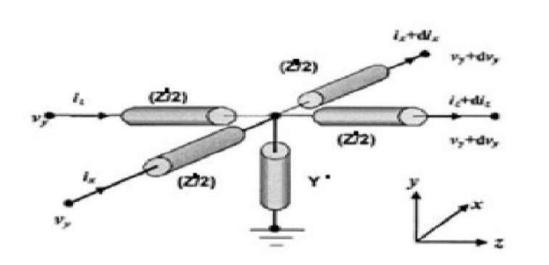Figure 1: Unit cell for a 2D distributed L-C network [2]

II. Left Handed Transmission line

1. Properties of a dual band TL [1]

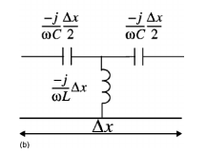Figure 2: Left handed Transmission line

Characteristic impedance :

Phase velocity :

Group velocity

Phase constant β ;

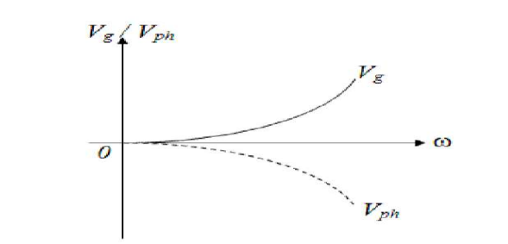Figure 3: Phase and group velocity versus angular velocity (w) [2]

2. Experimentation :
Let’s consider a 5 cells transmission line with Zc= 50 ohm fixed L=0.250e-6 H C=100e-12F for F= 2GHz

Vph=-62.83m/s
Vg= 62.83m/s

β=-200.0058 rad/m

3. Dispersion diagram : (see figure 8)
F(GHz) |  |  |  | 1 | 2 | 4
Vѳ ( m/s) |  |  | 1.97e9 | -1.97e11 | -7.89e11 | -3.14e12

W(rad/s) | 6.28*10^6 | 62.8*10^7 | 0.62*10^9 | 6.28*10⁹ | 12.56*10⁹ | 25.12*10⁹
β(rad/m) | - 31.82 | -31.87 | -0.314 | -0.031 | -0.0159 | -0.008

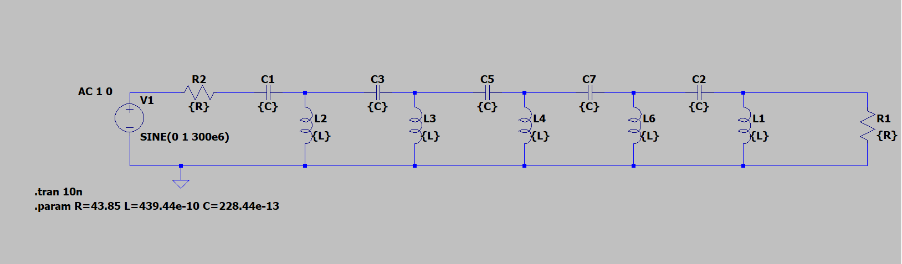Figure 4: five cell Left handed TL

4. Result analysis :
we can notice that there is a phase advance

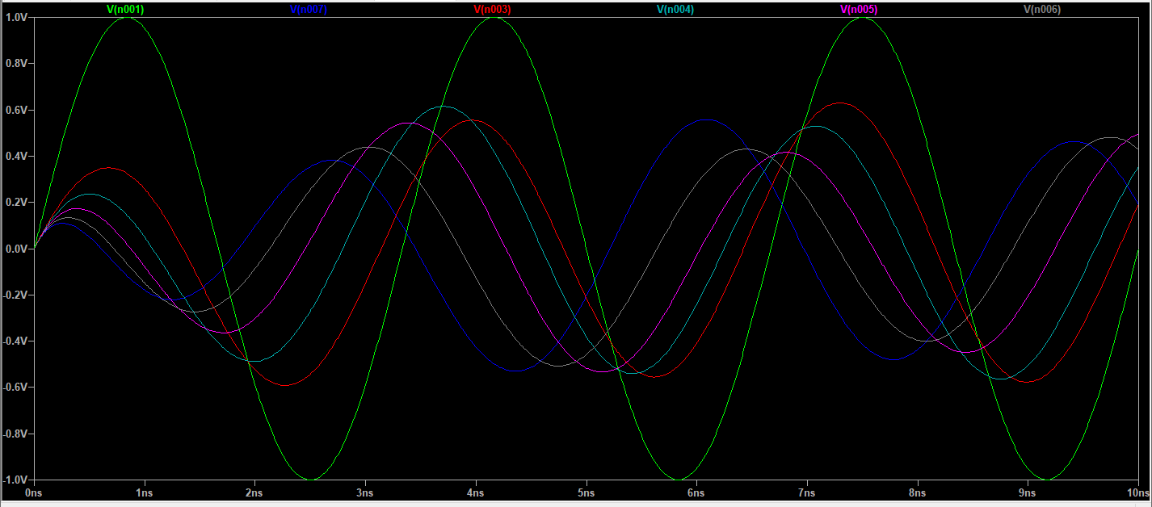Figure 5: Time domain simulation of the Left Handed TL

When we have a look on the magnitude
we found a high band pass filter

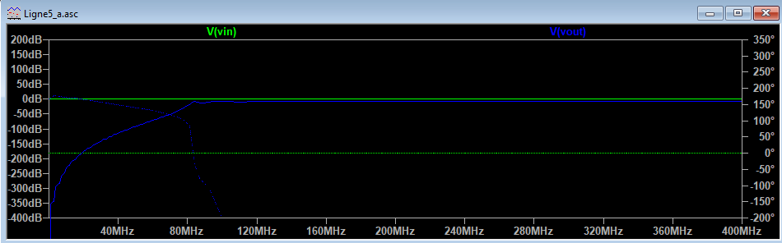Figure 6: Frequency domain simulation of Left Handed TL
Left-handed transmission lines can exhibit a reversed relationship between phase and group velocity compared to conventional lines (RH TL). This property allows waves to propagate in an opposite direction to their phase velocity, enabling unique wave manipulation.
This transmission lines can allow higher-frequency signals to pass through while attenuating or blocking lower-frequency signals. This behavior is akin to a high-pass filter where it selectively permits higher frequencies to propagate while restricting lower frequencies.

III. Real case simulation (CLRH TL)
1. Complementary Left Right Handed Transmission line
The previous schematic is not realistic in fact because it means that we need to cut conductors
In pratical case what we use is the Complementary left and right handed CLRH Transmission line
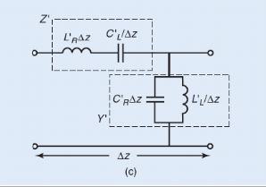Figure 7: Complementary right Ledt Handed TL Circuit

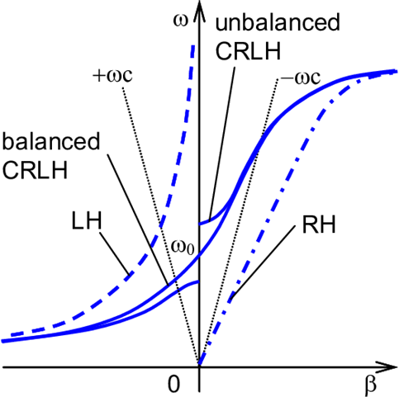Figure 8: Dispersion Diagram for LH; RH and CRLH TL [4]
2. Experimentation :
Let’s consider a 5 cells transmission line with Zc= 50 ohm fixed L=0.250e-6 H C=100e-12F for F= 2GHz

3. CRLH properties[2]:

Characteristic impedance :

Phase velocity :

Group velocity

Phase constant β ;

4. Simulation result :
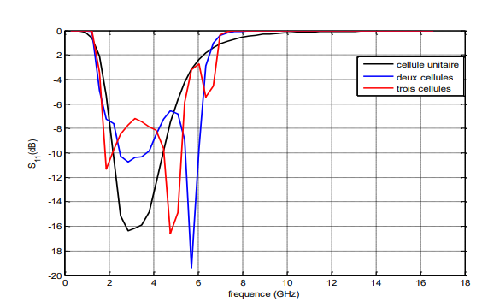Figure 9: Reflexion coefficient versus frequency

By viewing parameters S
S11 reflexinon coefficient on the input
we see that in some frequencies we have huge reflexion from 2GHz to 6GHz

The Transmission coefficient S21
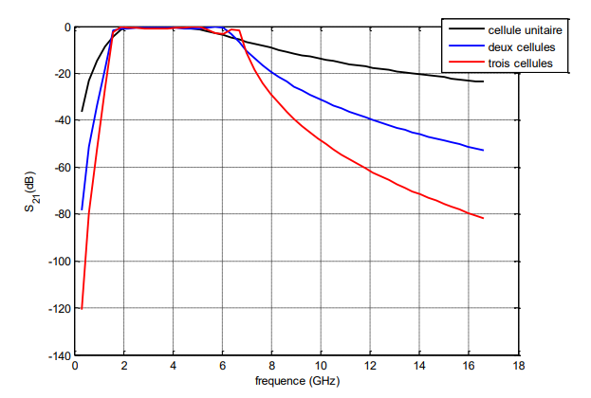Figure 10: Transmission coefficient S21

The transmission magnitude show us a pass band filter behavior
Notices :
The representation of the reflection coefficient S11 as a function of frequency for the various studied scenarios shown in Figure 11 demonstrates that these lines can be used as wideband matching elements. Overall, there is adaptation observed in the 2 GHz to 6 GHz band, with the reflection coefficient ranging between -7 dB to -19 dB.

IV. Application of the CRLH
Composite Right/Left-Handed (CRLH) transmission lines are utilized in various applications across different fields due to their unique properties and abilities to control electromagnetic waves. Some of their applications include:
1. Antennas: CRLH structures are employed in antenna design to achieve compact, multifunctional, and wideband antennas. They enable the miniaturization of antenna systems while maintaining or enhancing their performance characteristics.
2. Filters: These transmission lines are used in the development of compact and tunable filters, enabling the creation of high-performance filters with adjustable bandwidths and frequencies. They find applications in communication systems, radar, and microwave circuits.
3. Metamaterials: CRLH structures are integral components in the creation of metamaterials. They enable the manipulation of electromagnetic properties, leading to innovative functionalities such as negative refraction, sub-wavelength imaging, and cloaking devices.
4. Signal Processing: In signal processing applications, CRLH transmission lines are employed in phase shifters, delay lines, and beamforming networks. They contribute to the control and manipulation of phase and signal propagation.
5. Integrated Circuits: These transmission lines find application in integrated circuits for microwave and millimeter-wave systems, facilitating the development of compact and efficient circuits with improved performance.
6. Wireless Communication: CRLH structures play a role in improving the efficiency and bandwidth of wireless communication systems, aiding in the development of high-speed and high-frequency wireless technologies.
V. Conclusion:
To sum up this research sheds light on a new type of transmission line and its distinct attributes. It's evident that frequencies significantly influence the impedance matching of this line, along with its functionality as a passband filter. The versatility and distinctive traits of the CRLH transmission line render it invaluable in diverse advanced applications within telecommunications, radar, imaging, and other domains reliant on managing electromagnetic waves.

VI. References :
[1] https://www.researchgate.net/publication/224490909_Experimental_verification_of_backward-wave_radiation_from_a_negative_index_metamaterial#pf2
[2] https://www.jpier.org/issues/reader.html?pid=13041803
[3] http://dspace.univ-medea.dz/bitstream/123456789/5153/1/M121236.pdf
[4] https://core.ac.uk/reader/40041960

